***Susan* *Mitra***

***White Lodge, 12, Wellesley Road, Chiswick, London, W4 4BL.***

***Email:susanmitra@btinternet.com***

***27th June 2014***

Dear Anil,

How are things with you? I now have my electric wheelchair but it is taking me a while to get used to using it as the paving slabs are so crooked here!!

My sister, Judi, and I went out to visit Ali a couple of weeks ago. We were meant to be flying with Vueling on 13th June at 18:55. I was not impressed with the way I was dealt with in Heathrow’s Terminal 3. The day was warm and we were left in a room without air conditioning. When I needed to use the toilets, I was told I had to take my luggage with me! It felt as though I wasjust a nuisance being disabled.

We got to the plane on time but it did not take off. We were initially told that there was a problem with the parking brake but later we were informed that there was a pot hole on the run way and that the wheel was stuck in it and we would have to be towed out! We were stuck on the plane for three hours before being taken back to the terminal. Vueling were going to put us up in a hotel but, as I live in Chiswick, I thought it would be easier to go home as I have an electric bed at home and, after such an experience, I knew I would sleep better at home. We therefore got a taxi back to my house.

In the morning, we rang Vueling to see when the flight would be and they told us 9:30. It actually did not leave till 12:30! We therefore lost a day of our holiday. Ali had said he would come and pick us up from Bilbao but I did not think his car would be big enough for our luggage and my wheel chair. I told him we would get the coach. Sadly, we missed the 3:30pm one by 10 minutes and then had to wait until 6pm. The coach journey from Bilbao to Pamplona is 2 hours and Ali came to meet us at Pamplona bus station. Amazingly, all our stuff did fit in his car so he could have picked us up! At least, I know that for another time. It took 20 minutes for him to drive us to Maneru, where his flat is.

His flat was lovely and I have inserted some pictures of the outside and the interior:

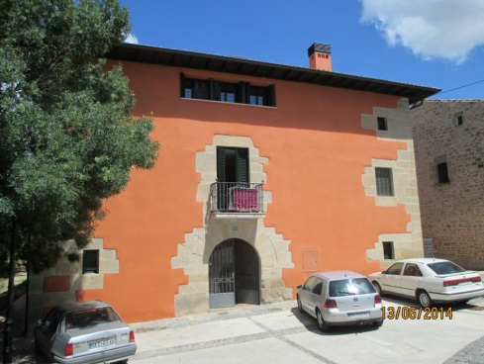

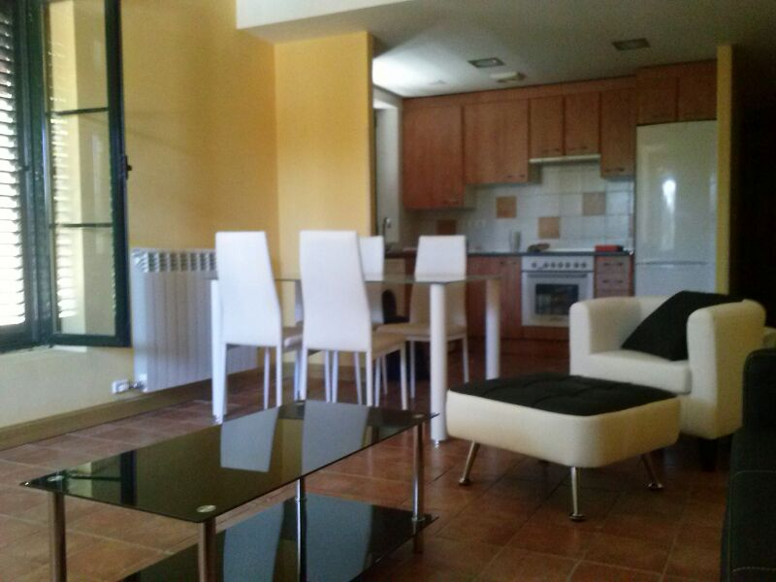

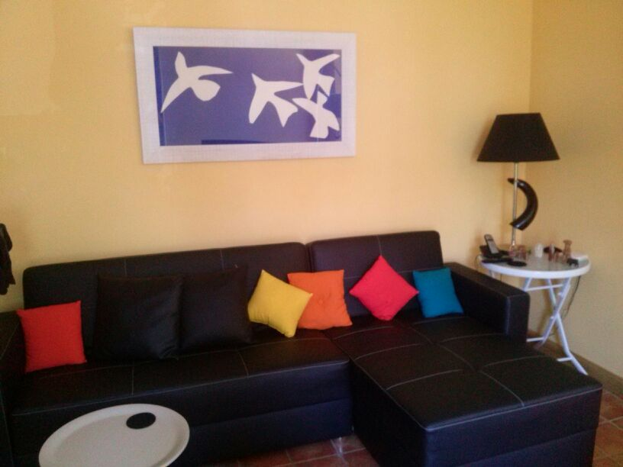

We arrived there about 9pm and the village is quiet. He has shutters on his windows so the room we were sleeping in was quiet and dark. I succeeded in sleeping 12 hours, with my ventilator on, and the following day I felt better than I had done in a long time. His flat was compact which meant I did not have to walk far, which allowed me to retain my breath. We basically just stayed in Maneru on our first day. Ali and Judi took me for a walk round the village in my wheelchair:

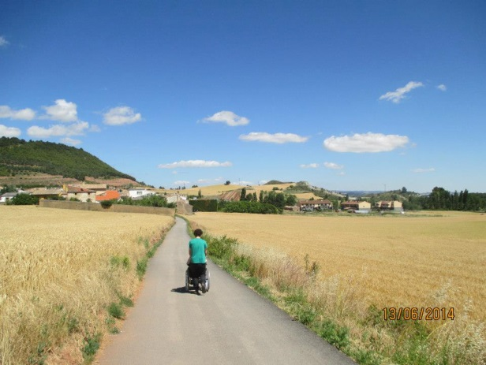

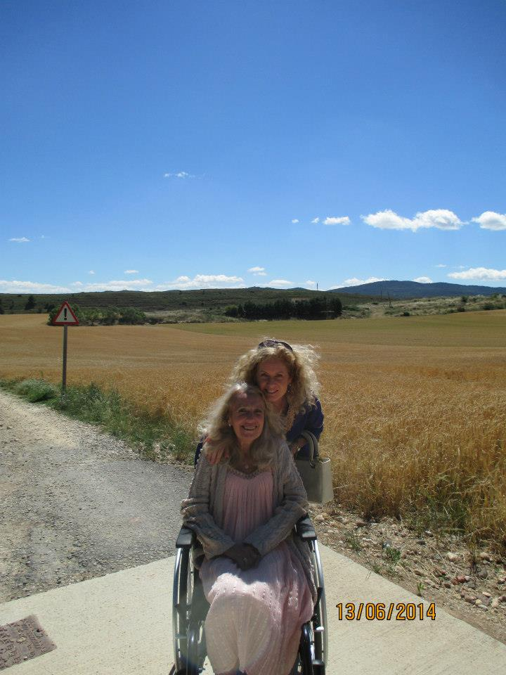

Later on, Roberto, Ali's partner, came to meet us. I have inserted a picture of Roberto, Ali and I below and one of Judi with him too:

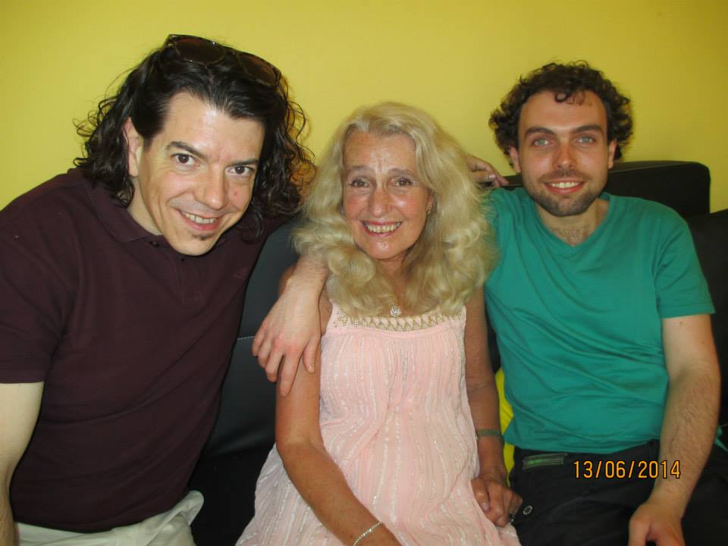

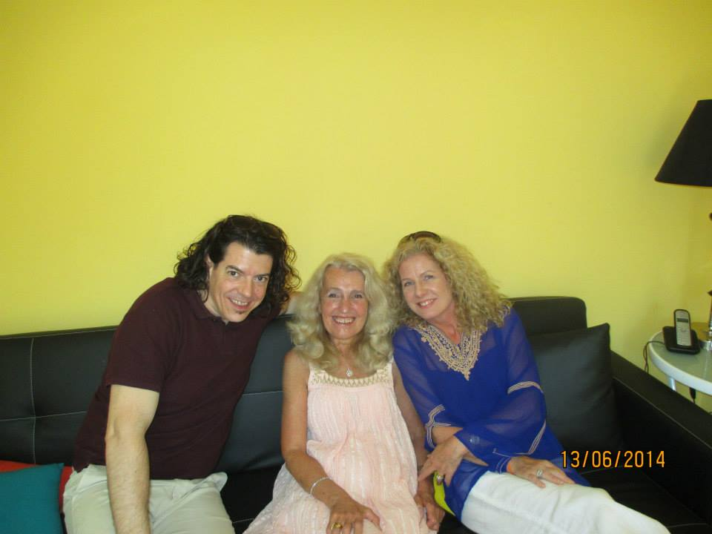

Judi and I really liked Roberto. In the early evening, Ali got a phone call from his father, in America, which really upset him. David is in hospital with colon cancer. They had removed half his colon but it has apparently spread to his lymph nodes and he has to undergo chemotherapy. I feel so bad for my two sons, as now both parents have life threatening conditions. Thank goodness for Robin!  At least, I was there to console Ali.

The following morning, Roberto drove us to San Sebastián. Judi thought it was the most pleasant place she has ever visited and I have inserted some pictures of the town:

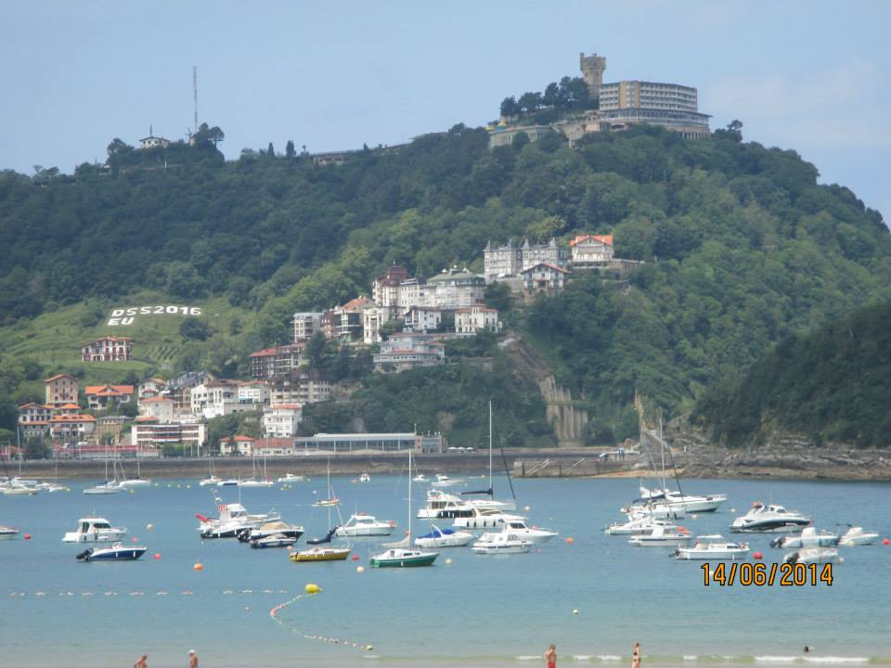



We had lunch overlooking the beach:

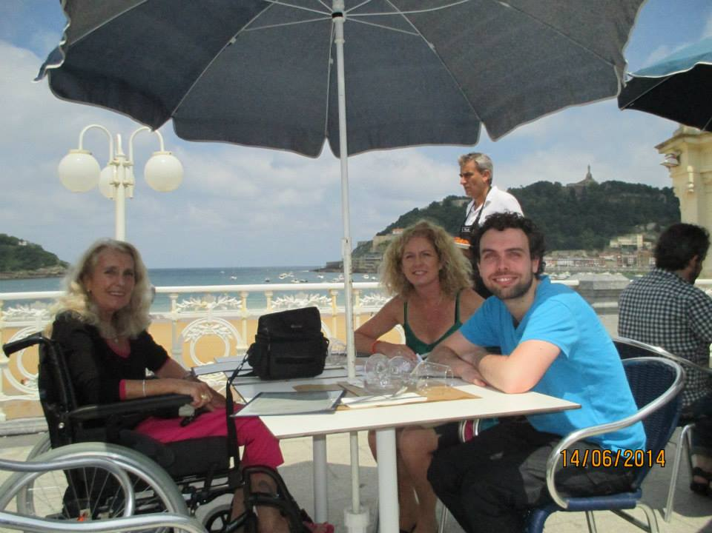

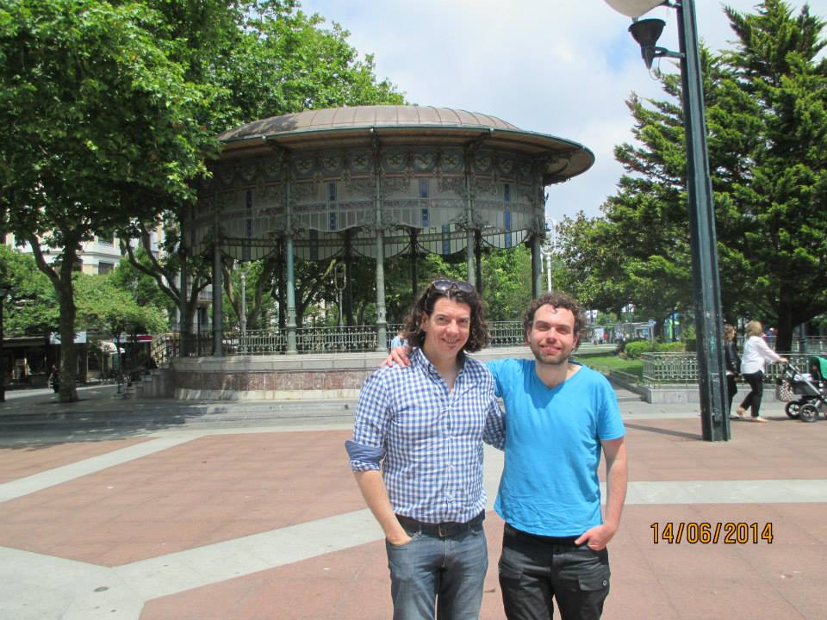

Roberto then drove us to Pamplona where we did some sightseeing and shopping. Judi and I wanted to buy Ali house warming presents. I am inserting a few photos below of Pamplona: 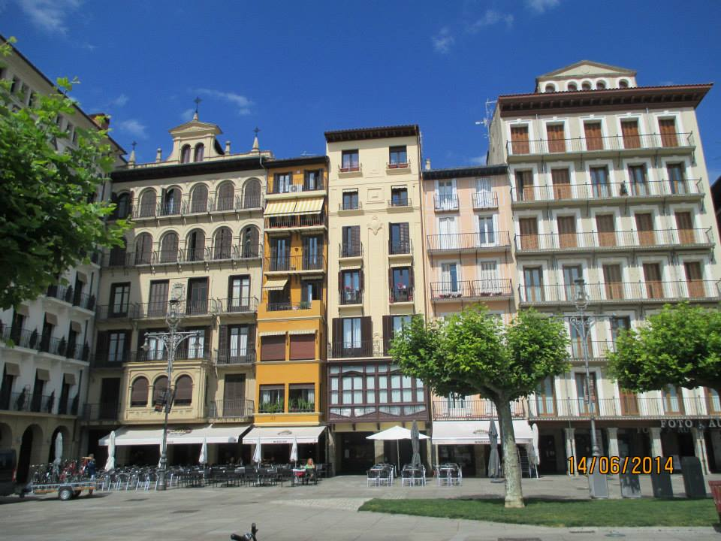

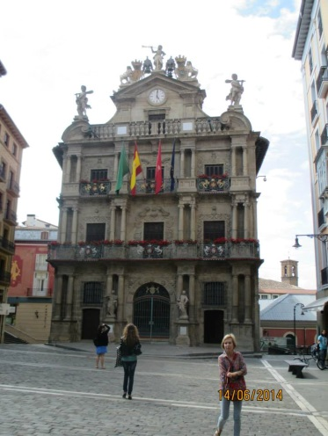

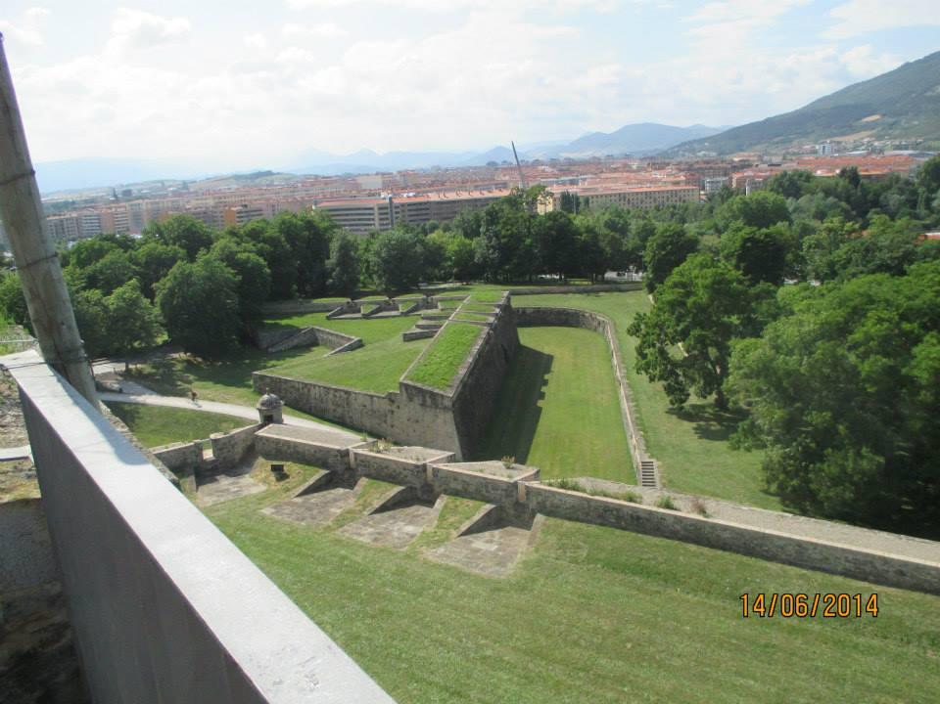

The next day Ali drove us to Bilbao and we were impressed with his driving. I have inserted a picture of him below with his car at Bilbao airport:

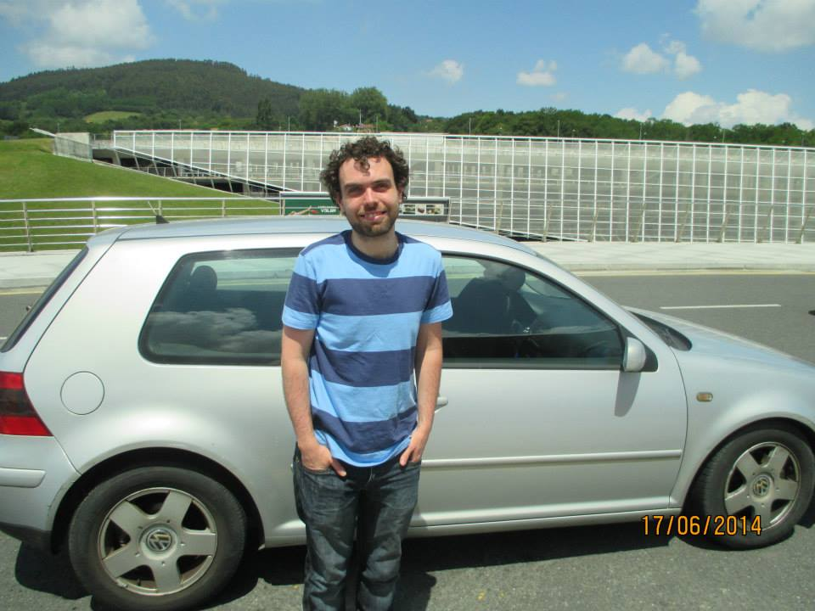

It will not be long until I see him again as he is coming home on July 4th and staying until July 16th. Roberto will be joining him from 8th July.

Our flight was thankfully on time and arrived at Terminal 3 at 18:15. However, I then encountered another problem as the lift was not working! We had to wait over an hour and a quarter with a Heathrow employee who had come to help us. He kept ringing for aid but to no avail. After an hour, someone came to direct us to another gate where the lift worked. I was shocked at how poor the attention was for disabled people at Heathrow. I was tired after the flight and did not expect to be at the airport till 7:45! I was treated so much better at Bilbao Airport and I really think Heathrow needs to do something to improve their treatment of the disabled as I was made to feel like I was a problem.

Last Thursday, I went to see the consultant and she was happy with me. She only thought my legs had got weaker but she also said I should have the operation to fit the feeding tube. Eating is becoming a nightmare as I simply do not have any appetite and I get full as the day goes on – presumably because I am not moving around much because of my breathlessness. She said if I do not have it soon, I will not be able to have it because of my breathing difficulties. She said it will prolong my life so I think I need to go ahead with it. However, I do not want to have it whilst Ali is here and therefore I have said from 17th July onwards. I will apparently have to be in hospital for 5 days. It leaves a tube sticking out of my stomach and I am not keen on it but if it helps me to live longer, then that is fine. They have just rung me to say they are going to do it on 23rd July and I need to go in to the London Hospital of Neurology the day before.

My brother,Jimmy’s, daughter got married last Saturday and they did not invite a single member of my brother’s family to the wedding!!!

Well, that is my news. Robin went to the dentist yesterday to have a crown put on but he has to wait 6 months before his missing tooth can be replaced!

My trip to Spain showed me it was OK to travel and therefore Robin and I have just booked to go to Tobermory, on the Isle of Mull. It is where I was born and lived the first 8 years of my life. Robin is going to drive up to Oban but we are going to make the journey in 2 days. We are going to leave tomorrow and catch the 6pm ferry over to Mull, on Sunday. We have booked into a hotel just a few doors away from where I was born! It is the Tobermory Hotel. We will be there on Sunday and Monday nights and will catch the 1pm ferry, back to Oban, on Tuesday. We will be back home on Wednesday 2nd. I am looking forward to seeing Tobermory again, but the weather forecast does not look good.

I hope that all is well with you.

Lots of love

Susan

XX